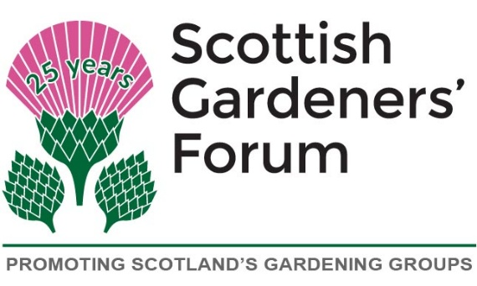 | Scone Palace Garden Fair, 2026  Entry Form for the SGF  Planter Challenge  Friday 29th & Saturday 30th May 2026, 10am-5pm

Application

We would like to participate in the SGF Planter Challenge 2026

Number of Planters: ..................................

Name of Organisation: …………………………………………..
Name and address of Contact Person:
………………………………………………………………………..
………………………………………………………………………..
………………………………………………………………………..
Please state how we can keep in touch with you:
Daytime Phone Number: …………………………………………
Evening Phone Number: …………………………………………
Mobile Phone Number: …………………………………………..
e-mail Address: ……………………………………………………

Send to:
Please submit your application by email to: chair@scottishgardenersforum.org.uk
Or by post to: Kathryn Pitts
11 MacCormick Terrace,
Penicuik,
Mid Lothian
EH26 0JX
Please register your interest as soon as possible.
NOTE: Entries are free of charge

